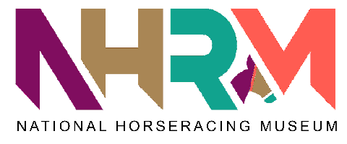
Volunteering: Expression of Interest Form
Your contact details
Name
Address
Telephone
E-mail

About you
Please provide a brief outline or any skills, interests or experience that you would like to bring to a volunteer role.

Volunteer Role
What do you hope to get out of volunteering?

What sort of role would you be interested in?

Your availability
Please provide an indication of what days/hours you are willing to commit to on a weekly basis:

How did you hear about volunteering with us?

Are you familiar with the museum?

Have you volunteered before?

Referees
Please provide contact details for 2 people who have known you for more than 2 years (not relatives or partners) who we can ask to comment on your suitability to volunteer for us.
Name
Address
Telephone
E-mail
Relationship  to you | Eg former employer, tutor, friend etc

Name
Address
Telephone
E-mail
Relationship
to you

I confirm that I am aged 18 years or older and am eligible to work/ volunteer in the UK.
Signed
-----------------------------------------------------------------
Date
-----------------------------------------------------------------
Please return to: Alice Sophia (asophia@nhrm.co.uk)
The personal information provided on this form will be stored securely in accordance with Data Protection legislation and will only be used by National Horseracing Museum in relation to our volunteering programme.
If we can’t match you to a suitable volunteering role at the moment, then we will be happy to advise you about where to look for information on other volunteering opportunities.

